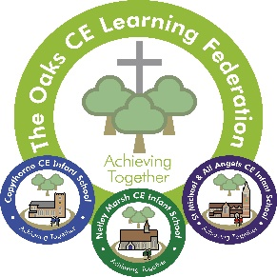

The Oaks CE Learning Federation Teaching and Learning Policy

Our Vision

Connected through the values of love, respect and compassion. Three separate schools, we journey together to grow physically, spiritually, emotionally and intellectually, so that everyone can fulfil their potential. We strive to preserve the wonder of childhood, whilst ensuring our children are future ready.
“Be strong and of good courage, do not be afraid nor be dismayed for the lord your God is with you wherever you go” Joshua 1:9

This policy aims to set out our rational for teaching and learning and how our vision and values underpin the work we do.
Three separate schools, we journey together…
As three schools, we seek to ensure that best practice is disseminated, through a consistent pedagogical approach, which is implemented, evaluated, adapted and positively impacts on learning.
At the Oaks Federation, we used a shared curriculum across our schools which has been developed collectively by our teaching team.
…to grow physically, spiritually, emotionally, and intellectually
Physical growth:
At the Oaks Federation we promote the physical growth of every child through our provision.
- Children should have opportunity to:
- Learn outside
- Practice core gross and fine motor skills, both discretely and through other learning activities, including building, making, handwriting opportunities etc.
- Be physical, being given at least 30 minutes of physical exercise every day through fit breaks, active play times, P.E lessons, active learning activities.
- Develop practical ‘life’ skills, including getting changed for P.E, cutting up food at lunch time, learning to fasten coats and tie laces.
Spiritual Growth
At the Oaks Federation, we have defined spirituality as ‘seeing the wonder in everything around us’
Therefore, in order to develop children’s spiritual growth, our provision must include:
Build in time to look and reflect
Create ‘experiences’ to remember forever
Create opportunities to reflect and ‘draw breath’
Explicit opportunities to teach social interactions
Opportunities to speculate, ask questions and wonder
Dedicated time to teach ‘expectations’ for behaviour as well as discuss the impact our behaviours have on others.
Emotional Growth
As part of our provision, we explicitly teach children the language to converse, negotiate and communicate how they are feeling. This is done through subjects such as relationship education, through worship and as opportunity occurs throughout each day. As part of our behaviour policy, we advocate emotional coaching to support children in understanding the impact of actions and knowing how to make things better. There are opportunities for children to won and loose and grow emotionally form the experience of both.
Intellectual Growth
In the Oaks CE Learning Federation, we ensure children are taught basic skills and given opportunities to apply these across the curriculum. When new concepts are taught and understood by children, we seek to extend children through application, questioning and deepening knowledge and not through rapidly moving through new content, to ensure deep routed intellectual growth. We ensure that as well as teacher directed leaning, all children have the opportunity to choose aspects of their learning to extend i.e. through discovery time etc.
everyone can fulfil their potential
We regularly assess children to celebrate successes and to ensure that next steps in learning are appropriate for every individual children. We recognise effort and attitudes towards learning and seek to teach through a broad range of topics, to allow every children find interest in what they are learning. We regularly review children’s progress and alter provision where needed to support every children to reach their potential.

We strive to preserve the wonder of childhood
We teach in a thematic way, ensuring that our themes are age appropriate and tap into the interests of our pupils, at the start of their educational careers.
We look to include first hand experiences and create memories through our learning, to ensure that every child leaves with a positive image of school and a thirst to continue their learning journey.
We embrace special days and celebrate those things which are important to our children, as well as provide new experiences as often as possible.
We recognise the importance of resources, imagination and level of activity appropriate for our age ranges being taught.
whilst ensuring our children are future ready
our pedagogy must ensure children are explicitly equipped the skills to work collaboratively, persevere and understand how to improve as well as recognise success in themselves and others.
“Be strong and of good courage, do not be afraid nor be dismayed for the lord your God is with you wherever you go” Joshua 1:9
We teach our children that God wants us to be the best we can be, and even when things are hard, to remember to be bold and be strong because God is always with us.

Curriculum Design
We teach through a thematic approach, to excite our children and also support children in making connections between different aspects of the curriculum.
When our children leave us, at the end of Year Two, we aim for our pupils to be:
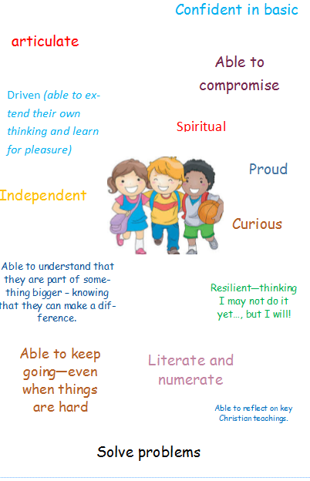
Our curriculum is designed, with the intention of every pupil reflecting these skills.

Key Aims of our curriculum
- Driven by narrative
- Make a difference – be courageous advocates
- Age appropriate – enhance childhood!
- Active
- Combine teacher directed, teacher initiated and child directed learning
- Promote social development
- Accessible for all
- Provides a concrete start – for all children to build upon
- Bridges learning – make connections between learning areas
- Develop social conventions – teaches children how to work collaboratively
- Provides cognitive challenge – makes children think

Thematic approaches
We aim to make strong links between curriculum areas and to deliver learning through themes, which engage and interest our learners. Themes are planned for different periods of times, depending on the learning content being taught. Some themes may last for a period of days and others for a period of weeks. Some themes are revisited year on year (such as Christmas!)
Our Vision
Over each half term, our teachers will plan opportunities to enhance our provision and help us live our vision these include:
Living our vision
Each half term, curriculum will provide all children with:
Opportunity to involve parents  (wonder of childhood)  (love, respect and compassion) | Outdoor provision  (grow physically) | Visitor to school  (grow emotionally)  (love, respect and compassion)
Offsite visit  (wonder of childhood) | Exciting hook  (wonder of childhood) | Cross federation, shared experiences.  (three schools journey together)
Exciting experiences!  (wonder of childhood) | Opportunity to make the world a better place  (grow spiritualty)  (love, respect and compassion) | Try something new  (future ready)

Grow intellectually
We have a clear and progressive curriculum, with pedagogy and key learning map out for each subject. These are published on our website https://www.oakscelearningfederation.co.uk/curriculum/
These form the basis for our learning journey.

Some subject areas will be taught each half term – including:
Literacy
Math
Music (discrete)
R.E
PSHE/Relationship (including safeguarding)
Science
Computing
P.E
Safeguarding
Other subjects will be taught in blocks at least once each term, including:
Art
DT
History
Geography
Teachers plot out learning journeys for each half term, documenting key learning, experiences and events.
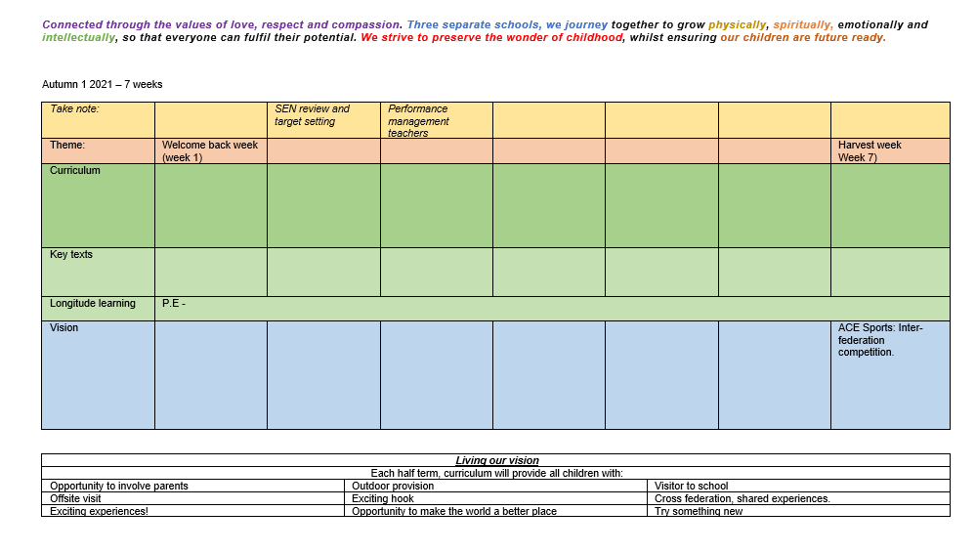
Lesson Pedagogy
At the Oaks, we work to ensure there is a consistent underpinning pedagogy across the curriculum.
For most subjects, pedagogy intention is detailed through curriculum documents, found on our school website https://www.oakscelearningfederation.co.uk/curriculum/
At the Oaks, we regularly review teaching and learning. Each teacher uses his/her professional judgement to tailor learning to ensure every child is able to building on previous learning and meet success. At the same time, there are key components, which we would expect to see in every lesson:
Sharing of learning objectives and success criteria – so that children understand their learning and can reflect on their personal level of success.
Tasks are designed to be open ended in design so that children can extend their own leaning and push themselves to achieve more.
Learning is differentiated to meet children’s needs and build on next steps
Lesson structured is carried to avoid teaching children concepts they are not yet ready for or have already mastered – so that all children make good progress in lessons.
Children should have a balance of teacher directed and child directed learning as well as adult supported work and independent work, allowing children to apply and consolidate what they have been taught.
Promote our learning values - https://www.oakscelearningfederation.co.uk/learning-values/
Promotes AfL strategies within lessons (assessment policy)- including opportunities for peer and self evaluation – do that children take greater ownership over learning and misconceptions are addressed quickly within lessons.
Ensures that additional adults are well utilised and making impact from start to end of each lesson.
Dedicated time to subjects
We aim for our school day and term to be as flexible as possible. Many lesson will not fit into a time allocated slot. This means that for some curriculum areas, classes may take a day to fully explore learning and for other curriculum areas of learning, a series of short lessons. However, as a minimum, within our schools we do:
- Invite all to whole class prayer
- Daily collective worship (either as a class or whole school)
- Provide time for children to investigate, consolidate and extend learning through ‘exploring time’
- Teach daily phonics
- Teach daily reading (see reading policy)
- Teach at least 4 hours of discrete math each week
- Teach at least 2 discrete P.E session per week
- Teach at least 4 hours of discrete literacy per week
- Make opportunities to apply reading, maths and writing across the curriculum.
- Teach one weekly music session
- Teach discrete handwriting skills each week.
- Ensure there is opportunity for children to reflect on the week
- Every class will have story time at least once every day.
This policy should be read in conjunction with:
Behaviour policy
Home learning policy
Safeguarding policy
Worship policy
Relationship policy
Subject curriculum documents
Assessment policy
Marking Policy
Worship policy
Environment policy

